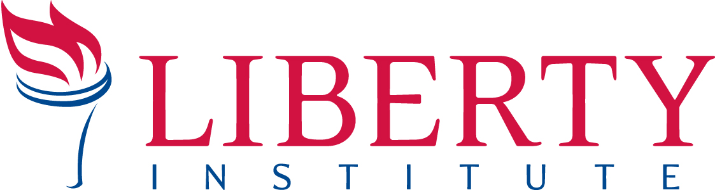
PRESS RELEASE
For Immediate Release

Contact: Kassie Dulin, Direct: 972-941-4575, Cell: 214.542.4334, Email: kdulin@libertyinstitute.org

OFFICIALS IN JEFFERSON PARISH COME TO CHURCH, FINGERPRINT PASTOR, AND ISSUE CRIMINAL SUMMONS AGAINST HIM FOR CHURCH BEING “TOO LOUD” AT CHRISTMASTIME
After Vintage Church pastor issued criminal summons for violating a noise ordinance,
Liberty Institute files a lawsuit to protect the church

NEW ORLEANS, LA, December 11, 2015 — Yesterday afternoon, Vintage Church filed a lawsuit against Jefferson Parish for violating Vintage Church’s rights under federal and Louisiana law. So far, officials in Jefferson Parish issued two criminal summons to Vintage Church’s executive pastor, ordering him to appear before a court in January, as well as fingerprinting him at the church, in front of the church members. Read the petition: libertyinstitute.org/vintagechurch

While Vintage Church, located in a New Orleans suburb, is undergoing construction, members are meeting in a tent on the church property on Sunday mornings. After a disgruntled neighbor complained that the church’s outdoor services were too loud, officials in Jefferson Parish issued a summons to the executive pastor for breaking a noise level of 60 dB—which, according to the American Speech-Language Hearing Association, is the noise equivalent of a running dishwasher or a typical conversation.

The church has made every effort to keep the noise level as low as possible, including hiring a sound engineer to keep the volume low. They even held worship services with no sound amplification—not even letting their pastor use a microphone and losing their ability to show Advent videos. Nevertheless, the parish issued another summons against Vintage Church executive pastor Matthew Brichetto, ordering him to appear before a Louisiana court on January 11, 2016.

On behalf of the church, Liberty Institute and attorney Roy Bowes filed a lawsuit against Jefferson Parish. A hearing will be held on December 15, 2015.

Justin Butterfield, Senior Counsel for Liberty Institute, said, “The government’s demand that the services cannot exceed the noise level of a conversation is ridiculous. Power tools and demolition noises are allowed, but a relatively quiet church service is prohibited. This is illegal, violating state and federal law, and must stop.”

Vintage Church Lead Pastor Rob Wilton says, “Every year our church loves celebrating the Christmas season, and these restrictions have certainly affected our ability to provide this joyful time of worship. We are praying that this matter can get resolved quickly so we can get back to doing what we love most: serving the community and worshiping Jesus in freedom during Christmas and into the New Year."

Read more about the case: libertyinstitute.org/vintagechurch

About Liberty Institute
Liberty Institute is the largest nonprofit legal organization in the nation dedicated exclusively to defending religious liberty in America. Liberty Institute defends religious freedom for all.

To arrange an interview on this case, contact Kassie Dulin, Director of Legal Communications. Email: kdulin@libertyinstitute.org, Direct: 972-941-9575, Cell: 214-542-4334.

