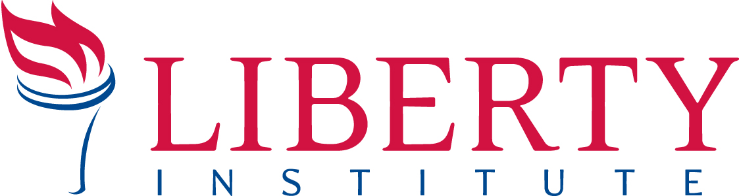

For Immediate Release PRESS RELEASE

Contact: Callie Walker, calliegracewalk95@gmail.com, Cell: 210.410.7810
Gregg Wooding, Cell: 214.558.9455, Office: 972.941.4453, gwooding@libertyinstitute.org

BRAWLEY UNION HIGH SCHOOL CENSORS SALUTATORIAN, VIOLATES CONSTITUTION
Liberty Institute Attorneys Send Demand Letter to Brawley Union High School District Officials on Behalf of Salutatorian Brooks Hamby

BRAWLEY, CA, June 18, 2014—On Wednesday, Liberty Institute sent a demand letter to Brawley Union High School District officials on behalf of its client, salutatorian Brooks Hamby, whose written speech school officials repeatedly rejected claiming, “reference to religious content is inappropriate and…will not be allowed.” Although Hamby eventually delivered a fourth version of his speech at his graduation ceremony, for school officials to censor three different versions of his speech – and then threaten to turn off his microphone – just because he wanted to reference his faith is a serious First Amendment violation.
In the letter, Liberty Institute attorneys request to meet with the Superintendent before July 11 to resolve the religious discrimination issues against Hamby. Specifically, they seek a public statement from Brawley Union High School District exonerating Hamby of any wrongdoing, and a statement from Brawley Union High School District that such religious censorship will not occur in the future. To view an online copy of the demand letter, follow this link: http://libertyinstitute.org/hamby
“No student should be censored for simply talking about their faith,” said Liberty Institute Senior Counsel Jeremy Dys. “The US Supreme Court has made clear that students do not surrender their First Amendment rights at the schoolhouse gate - or the graduation ceremony.”
After school officials rejected two drafts of Hamby’s graduation speech for what they considered unconstitutional and inappropriate religious references, Hamby received his third draft with all references to God, faith, and the Bible blacked out. Despite three rejections and the threat to have his microphone turned off, Hamby presented a fourth version of his speech at the graduation ceremony. Hamby’s speech contained nothing that could be considered obscene or proselytizing, but instead reflected his personal story of inspiration and faith as an integral part of his life.

Liberty Institute is a national nonprofit legal group dedicated to defending and restoring religious liberty across America — in our schools, for our churches, inside our military and throughout the public arena. Liberty’s vision is to reestablish religious liberty in accordance with the principles of our Founding Fathers. For information, visit www.LibertyInstitute.org.

-30

