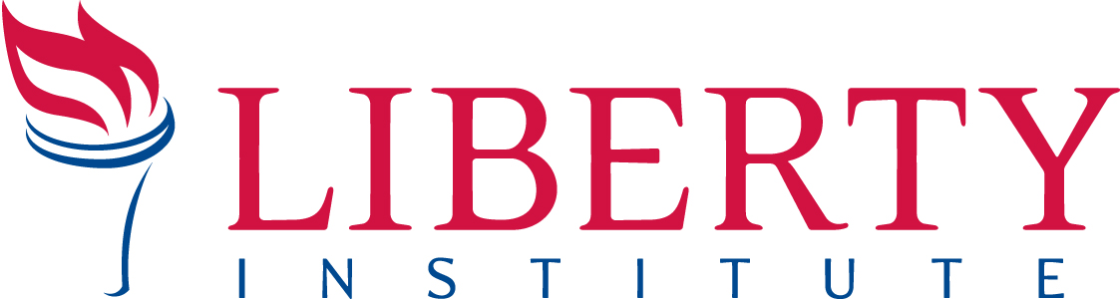
For Immediate Release PRESS RELEASE
Contact: Kassie Dulin, Cell: 214.542.4334, Office 972.941.4575 kdulin@libertyinstitute.org

CITY OF AUSTIN PAYS $480,000 IN ATTORNEY FEE SETTLEMENT IN FINAL COURT VICTORY FOR PREGNANCY RESOURCE CENTERS _____________________________________________________________________________
AUSTIN, TX, September 3, 2015—The City of Austin paid $480,000 in an attorney fee settlement in a case involving four Austin-area pregnancy resource centers. The settlement follows a 2014 Court ruling where a U.S. District Court judge ruled that a City of Austin ordinance regulating pregnancy resource centers was unconstitutional. View check: https://www.libertyinstitute.org/liberty_case/austin-pregnancy-resource-center

In a lawsuit against the City of Austin, Liberty Institute represented three Austin area pregnancy resources centers: The Gabriel Project Life Center (run by the Roman Catholic Diocese of Austin and Catholic Charities of Central Texas), the Austin Pregnancy Resource Center, and the South Austin Pregnancy Resource Center. The fourth center, Austin LifeCare, Inc. was represented by separate counsel. The four centers challenged the constitutionality of the ordinance as a violation of the First Amendment. The City of Austin adopted the unconstitutional ordinance at the urging of the National Abortion Rights Action League (NARAL).

The attorney fee payment will be distributed to attorneys for the four pregnancy resource centers, including the Liberty Institute, Bowman & Brooke, LLP, former Texas Supreme Court Justice Raul Gonzalez, Jubilee Campaign Law of Life Project, and the Texas Center for Defense of Life.

Jeff Mateer, General Counsel of Liberty Institute, says, “This attorney fee settlement sends a clear message to NARAL, Planned Parenthood, and governments everywhere: respect the rights of faith-based pregnancy resource centers. If you violate a non-profit’s rights, you will pay a steep price.”

Case History: Roman Catholic Diocese of Austin et al v. City of Austin
In January 2012, the City of Austin passed an ordinance requiring pro-life pregnancy resource centers to post conspicuous signs outside their centers with government-regulated messages about their licensing and services. However, federal law and state law have no similar regulations for facilities that provide the simple services offered by the pregnancy centers.

The ordinance threatened criminal penalties against pro-life centers who did not post signs in compliance with the ordinance. Following enactment of the ordinance, Liberty Institute filed a lawsuit challenging the constitutionality of the ordinance.

In 2014, a U.S. District Court Judge ruled that the ordinance violated the pregnancy resource centers’ rights and found the ordinance unconstitutional. NARAL has advised multiple cities to pass similar ordinances but every ordinance that has been challenged in federal court to date, including those passed by the City of Baltimore, MD and New York City, NY, has been partially or completely struck down.

About Liberty Institute: Liberty Institute is a nonprofit legal group dedicated to defending religious liberty in America – in our schools, for our churches, in the military and throughout the public arena. Visit LibertyInstitute.org for more information.
-- 30 --

