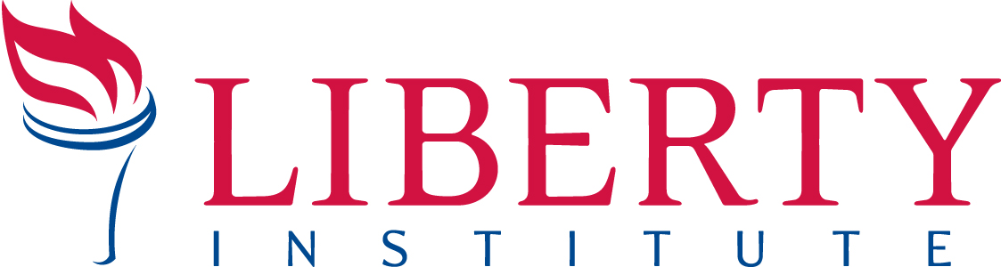
PRESS RELEASE
For Immediate Release

Contact: Kassie Dulin, Direct: 972-941-4575, Cell: 214.542.4334, Email: kdulin@libertyinstitute.org

Ms. Sophia Mao Smith, P.E., a member of the Johnson Space Center Praise and Worship club
who has worked at NASA’s Johnson Space Center for thirty years. (Photo courtesy of Ms. Smith)

LIBERTY INSTITUTE THREATENS TO SUE NASA
FOR CENSORING “JESUS” FROM EMPLOYEE EMAIL
Attorneys say that the government’s censorship of religious expression is illegal

HOUSTON, TX, February 8, 2016 – Today, Liberty Institute and attorneys from Fish & Richardson sent a demand letter to NASA’s Johnson Space Center (JSC), threatening a federal lawsuit over NASA’s censorship of “Jesus” from employees’ email announcement.

Read the demand letter: libertyinstitute.org/nasa

In 2001, employees at NASA’s Johnson Space Center formed the JSC Praise and Worship Club. They meet during the lunch hour to discuss matters of the Christian faith and sing Christian songs.

In one announcement, the JSC Praise and Worship Club announced that month’s theme for their meeting: “Jesus is our life.” Days after the announcement ran in the JSC daily newsletter, JSC Today, NASA’s lawyers called the club president to explain that the club’s announcement was unacceptable because it included the name “Jesus.” NASA lawyers claimed that if the name “Jesus” appeared in the email blast, it could make people think NASA was endorsing Christianity – even if it was very clear that the club, not NASA, made the announcement.

Liberty Institute says NASA is engaging in illegal government censorship by rejecting the employee speech because it has a religious viewpoint. The attorneys argue that NASA is violating the employees’ religious liberty and free speech rights in violation of the First Amendment and federal law.

“We are shocked that NASA would censor the name of Jesus from our Praise and Worship Club’s announcement,” said Sophia Smith, a NASA employee and club member. “NASA has a long history of allowing religious speech by employees. In fact, in 1968, Apollo 8 astronauts read from the Bible while they were orbiting the moon, and it was broadcast on TV. So why would they ban ‘Jesus’ from our announcements?”

“NASA has a long history of respecting the private, religious speech of its employees,” said Carl Bruce, Liberty Institute volunteer attorney and a principal in the law firm of Fish & Richardson. “That respect for the constitutional rights of NASA’s civil servants and contractors should continue, regardless of their religious viewpoint.”

“It is illegal for the government to censor the name of Jesus from emails authored by employees,” said Jeremy Dys, Senior Counsel for Liberty Institute. “Preventing a religious club’s announcement just because it contains the name ‘Jesus’ is blatant religious discrimination. We call on NASA to end their censorship and apologize.”

Read more about the case at libertyinstitute.org/nasa

About Liberty Institute
Liberty Institute is the largest nonprofit legal organization in the nation dedicated solely to defending religious liberty for all Americans.

To arrange an interview, contact Kassie Dulin, Director of Legal Communications for Liberty Institute. Email: kdulin@libertyinstitute.org, Direct: 972-941-9575, Cell: 214-542-4334.

# # #

