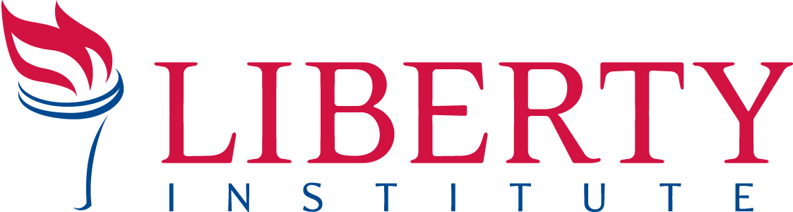

For Immediate Release PRESS RELEASE

Contact: Gregg Wooding, Cell: 214.558.9455, Office: 972.941.4453, gwooding@libertyinstitute.org

FEDERAL JUDGE GRANTS TRO IN FIRST
HHS MANDATE LAWSUIT IN STATE OF WEST VIRGINIA
Family-Owned Joe Holland Chevrolet Wins Federal Lawsuit Preventing Enforcement of the Federal Government’s Mandate to Provide Its Employees’ Abortion Coverage
____________________________________________________________________________
CHARLESTON, WV, June 26, 2013—Today, a federal judge for the United States of the Southern District of West Virginia at Charleston granted a temporary restraining order (TRO) to Joe Holland Chevrolet of Charleston, WV against the federal government’s HHS Mandate. The family-owned, faith-based car dealership is the first in West Virginia to contend and, now, to win injunctive relief from the HHS mandate, which violates the Religious Freedom Restoration Act and the First Amendment to the Constitution. To view a copy of the TRO online, visit:

Earlier this week, attorneys from Liberty Institute, the Family Policy Council of West Virginia, and Robinson & McElwee, PLLC filed the federal lawsuit to save Joe Holland from potential fines of up to $15,000 each day after July 1 for noncompliance in providing abortion-inducing drugs to its employees.

“We are relieved that the federal court has agreed that our client, Joe Holland, a respected Christian businessman known throughout West Virginia, should not have to violate his deeply held religious beliefs, nor be subject to crushing fines,” said Jeff Mateer, General Counsel for Liberty Institute. “The government should not be able to coerce family-owned and faith-based businesses to violate their religious beliefs.”

Holland’s case joins 61 other cases and more than 200 plaintiffs nationwide contending that the HHS mandate violates the Religious Freedom Restoration Act and the First Amendment to the Constitution. To date, 21 courts have granted injunctive relief prohibiting enforcement of the HHS mandate against businesses asserting violation of their religious beliefs. The lawsuit papers can be downloaded at http://www.libertyinstitute.org/document.doc?id=90

“This is a great victory for West Virginians who simply want to live out their faith in public,” said Jeremiah Dys, President of the Family Policy Council of West Virginia.

Joe Holland Chevrolet is a family-owned and operated car dealership located in South Charleston, WV with more than 150 employees. The dealership’s purpose is “to glorify and honor God by being faithful stewards for all that is entrusted to us.” The objection to the HHS mandate stems from Holland’s commitment to operate his business in accordance with his Christian faith, which includes his conviction that his business close on Sundays.

Liberty Institute is a nonprofit legal group dedicated to defending and restoring religious liberty across America — in our schools, for our churches and throughout the public arena. Liberty’s vision is to reestablish religious liberty in accordance with the principles of our Founding Fathers. For information, visit www.LibertyInstitute.org.

The Family Policy Council of West Virginia is a servant organization that advocates for policies that embrace the sanctity of human life, enrich marriage, and safeguard religious freedom. Advancing, defending, and equipping West Virginia's families through policy, politics, and preparation at FamilyPolicyWV.com.

-30-

