PRESS RELEASE
Embargoed until June 20, 2016, 8:00 am ET
Contact: Kassie Dulin, kdulin@firstliberty.org
Cell: 214-542-4334, Direct: 972-941-4575

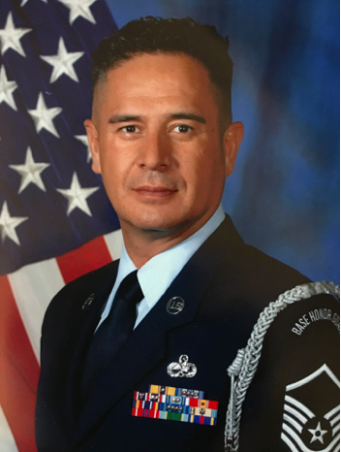
Oscar Rodriguez. Photo courtesy of Oscar Rodriguez. May be republished.

Read more about the case and access full resolution photos and video at FirstLiberty.org/Rodriguez

ATTORNEYS DEMAND JUSTICE FOR AIR FORCE VETERAN KICKED OFF MIILITARY BASE OVER SPEECH INCLUDING THE WORD “GOD”
After Airmen assaulted Oscar Rodriguez at a private military retirement ceremony
for giving a patriotic flag-folding speech that included the word “God,”
attorneys send letter to military commander demanding justice

SACRAMENTO, Calif. – Today, First Liberty Institute sent a demand letter to military leaders, asking them to apologize for assaulting Oscar Rodriguez, a decorated Air Force veteran with over thirty years of military service, and kicking him off Travis Air Force Base for giving a speech that included the word “God.”

Read the demand letter: link

Air Force Master Sergeant Charles Roberson heard Rodriguez deliver a patriotic flag-folding speech at a retirement ceremony and asked Rodriguez to give the same speech at Roberson’s retirement ceremony on April 3, held at Travis Air Force Base. “I saw Oscar perform the speech live just one month prior to my own retirement ceremony and I really wanted him to be able to perform that same way at my ceremony,” said MSgt Roberson.

Watch video of MSgt Roberson: link

Rodriguez agreed to Roberson’s request, but when he began the patriotic flag-folding speech at the retirement ceremony, multiple uniformed Airmen assaulted and forcibly removed Rodriguez because his speech included the word “God.” After being dragged out of the retirement ceremony, Travis Air Force Base personnel ordered Rodriguez off the base.

Watch video of the assault: link

“It was one of the most humiliating experiences of my life,” says Rodriguez. “I have given more than three decades of service to the military and made many sacrifices for my country. To have the Air Force assault me and drag me out of a retirement ceremony simply because my speech included the word ‘God’ is something I never expected from our military.”

“The Air Force had no right to assault a citizen, much less a 33-year military veteran, because they didn’t want him to mention ‘God,’” says Mike Berry, Director of Military Affairs for First Liberty Institute. “Mr. Rodriguez has a constitutional right to free speech and religious expression, even on a military base. The military broke the law and abused its power. We expect the Air Force to hold those responsible accountable, and allow Mr. Rodriguez to continue honoring the flag and other veterans who have sacrificed for our country.”

Read more about the case at FirstLiberty.org/Rodriguez

About First Liberty Institute
First Liberty Institute is the largest legal organization in the nation dedicated exclusively to defending religious freedom for all Americans.

To arrange an interview, contact Kassie Dulin, Director of Legal Communications for First Liberty Institute. Email: kdulin@firstliberty.org, Direct: 972-941-9575, Cell: 214-542-4334.

# # #

