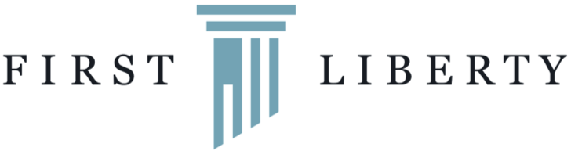
News Release
For Immediate Release: 4.4.19
Contact: Lacey McNiel, media@firstliberty.org
Direct: 972-941-4453

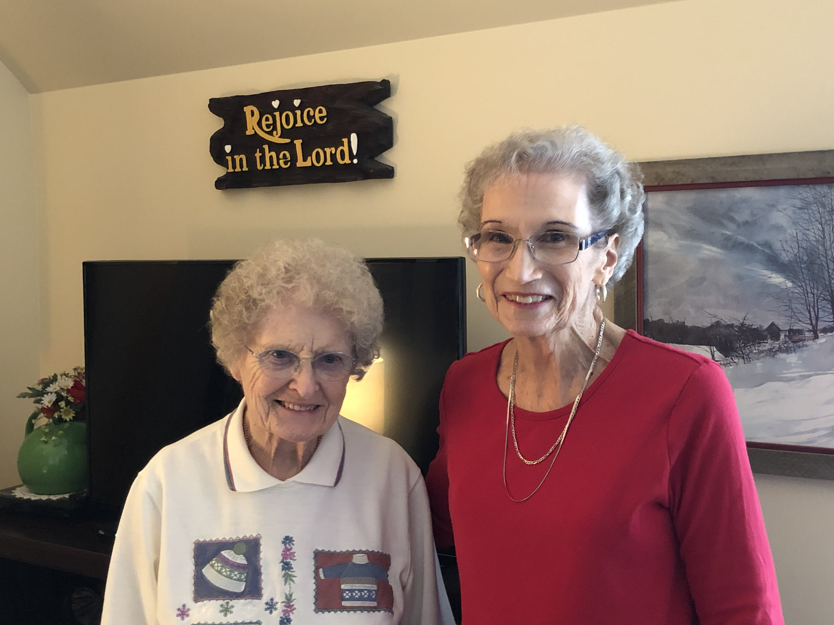
(Left to right: First Liberty Institute clients Wilma Wells and Joan Wilson.
Photo may be used with credit to, “First Liberty Institute” or “FirstLiberty.org”)

Michigan Senior Center Employee Censors Charlie Brown During Resident Led Christmas Reading Time for Kids
First Liberty Institute represents resident abruptly prohibited from reading “A Charlie Brown Christmas” to visiting pre-school students due to its religious content

Kalkaska, MI—First Liberty Institute today sent a letter to the government-owned Kalkaska (MI) Memorial Health Center (“KMHC”) asking that it institute policies ensuring that its employees will abide by laws protecting the First Amendment rights of its senior living center residents. In December, an employee of KMHC prohibited a resident from reading sections of “A Charlie Brown Christmas” to visiting pre-school children because it contained religious content. The letter also asks KMHC officials to apologize to the residents involved.

You can read the letter, here.

“There’s nothing quite like a government Grinch crushing the spirit of Christmas,” said Keisha Russell, Associate Counsel for First Liberty Institute. “Our clients were simply exercising their constitutionally protected rights by reading a much beloved Christmas story to children when they were silenced. KMHC needs to ensure that the rights of its residents are protected and issue an apology.”

Just before Christmas, students from KMHC’s Child Development Center and Pre-School (“CDCP”) visited residents of KMHC’s Assisted Living Center. As part of this visit, the elderly residents of the Center read Christmas stories to the students. One resident read Tim Burton’s “The Nightmare Before Christmas” without incident. When another resident, First Liberty client Wilma Wells, asked the children if they knew why Christmas is celebrated, an unidentified CDCP employee accompanying the students interjected, stating “We won’t go there, Wilma.”

Later, First Liberty client Joan Wilson was reading “A Charlie Brown Christmas” to the students, and while explaining Linus’s historical account of the Christmas story, the same employee interrupted, abruptly canceled the visit, and escorted the children out before Mrs. Wilson could finish.

In its letter, First Liberty argues that the CDCP employee violated the free speech and free exercise rights of the residents because they are private citizens whose speech, including religious speech, is protected by the First Amendment. It also argues that when a government employee, such as the CDCP teacher, censors or bans certain speakers or speech purely because of its religious motivation, it constitutes illegal “viewpoint discrimination.”

###

About First Liberty Institute
First Liberty Institute is a non-profit public interest law firm and the largest legal organization in the nation dedicated exclusively to defending religious freedom for all Americans.

To arrange an interview, contact Lacey McNiel at media@firstliberty.org or by calling 972-941-4453.

